# 2100030325

# M . Charan Sai Chowdary

# Mass Mailing using AWS Lambda

AWS Lambda can be used to send out mass emails. It allows you to quickly and easily send out emails to a large number of recipients without having to manually set up and manage a mail server.

To get started, you will need to create an AWS Lambda function that will handle the sending of emails. You can use the AWS SDK for Node.js to create the function. Once you have created the function, you will need to configure it to send out emails.

To configure the function, you will need to set up an SES (Simple Email Service) account. This will allow you to send emails using AWS Lambda. Once you have set up the SES account, you will need to configure the function to use the SES account.

Once the function is configured, you will need to create a list of recipients that you want to send emails to. You can use a CSV file or a JSON file to store the list of recipients. Once you have the list of recipients, you can then use the AWS SDK to send out the emails.

To send out the emails, you will need to provide the AWS SDK with the list of recipients, the subject of the email, and the body of the email. Once you have provided the AWS SDK with this information, it will take care of the rest.

Mass mailing using AWS Lambda is a great way to quickly and easily send out emails to a large number of recipients. It is easy to set up and configure, and it can save you time and money.

If you have any questions about mass mailing using AWS Lambda, please feel free to contact us at cherrychowdary68@gmail.com.

SOURCE : [cherrychowdary68@gmai.com](mailto:cherrychowdary68@gmai.com)

DESTINATION : [waterbottlesupplier@gmail.com](mailto:waterbottlesupplier@gmail.com)

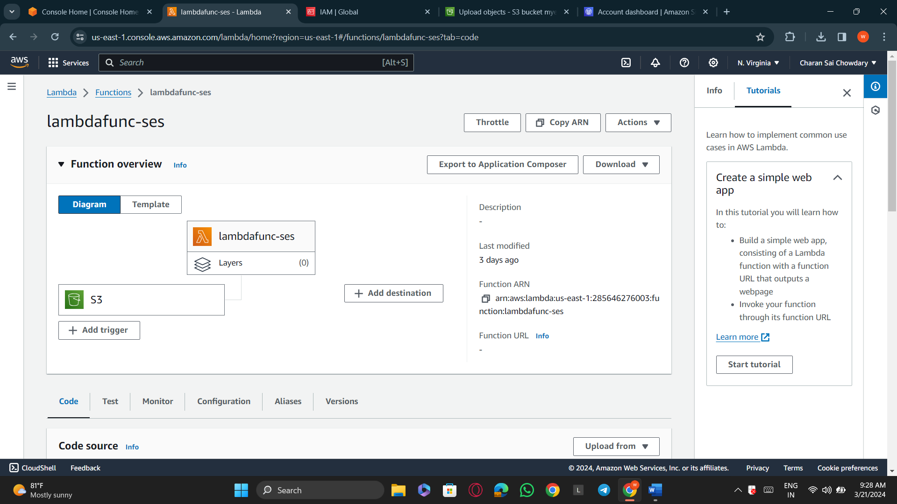

Final Output:

